1. Text

   Description automatically generated
2. 
3. In the earlier section, we learnt a lot about bringing data to the kafka Cluster.
4. Kafka Producer is critical part of our streaming app as they are responsible for originating the data streams and brining them to Kafka Cluster.
5. Once your streams start flowing into Kafka, we’re ready to tab into these streams and plugin our stream processing apps.
6. 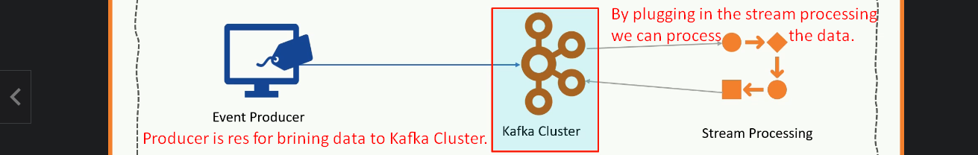
7. 
8. There are many ways to create Stream Processing Applications.  
   Diagram

   Description automatically generated
9. Kafka offers us three tools for this purpose.
   1. **Consumer API**: To create stream processing app and this is what we’re going to learn in this section.  
      But the Stream API & KSQL are beyond this course as requires a separate training.  
      Mentor: I have independent course for real-time processing using Stream API.
   2. **Stream API**:
   3. **KSQL**: